**STUDY OF ROAD CONNECTIVITY IN OGBOMOSO NORTH**

**BY**

**AKINDEERE, ZAINAB ABIKE (182615)**

**BEING A PROJECT SUBMITTED TO**

**THE DEPARTMENT OF TRANSPORT MANAGEMENT,**

**FACULTY OF MANAGEMENT SCIENCES,**

**LADOKE AKINTOLA UNIVERSITY OF TECHNOLOGY**

**OGBOMOSO, OYO STATE, NIGERIA.**

**IN PARTIAL FULFILMENT OF THE REQUIREMENTS FOR THE AWARD OF**

**BACHELOR OF TECHNOLOGY (B. TECH) IN TRANSPORT MANAGEMENT.**

**DECEMBER 2023.**

# CERTIFICATION

This is to certify that all the activities in this project report was carried out by **Akindeere, Zainab Abike (Matric No: 182615)** of the department of Transport Management, Faculty of Management Sciences, Ladoke Akintola University of Technology, Ogbomosho, Oyo State, Nigeria.

__________________ ____________________

DR. O.J Babalola Date

Supervisor

____________________ ____________________

PROF. Remi Aworemi Date

Head of Department

# DEDICATION

This project is dedicated to the Almighty God who has been my source of Strength, Grace and Wisdom throughout the period of my course, through whose Grace and Favor I have been able to run my course and scale through the hurdles of my academic pursuit.

# ACKNOWLEDGEMENT

The success and the outcome of this project were possible by the guidance and support of many people. I am incredibly privileged to have got this all along with the achievement of my project. It required a lot of effort from each individual involved in this project with me and I will like to thank them.

I appreciate the effort of my supervisor, DR. O.J BABALOLA**,** for granting me an opportunity to do the project activity in and providing us with all support and leadership, which made me finish the project duly. I am really thankful to the entire staff of the departments. You are surely voicing to reckon with in the department of transport management.

My boundless gratitude goes to my loving and caring father and mother**,** who has always been there whenever I need them. I also want to thank them for their moral and financial support. I wish to appreciate all my siblings, project mate, departmental mate for their immense contribution towards the project. May God bless you all.

# TABLE OF CONTENTS

Title Page 1

Certification ii

Dedication iii

Acknowledgement iv

Table of Contents v

List of Figures vii

List of tables viii

Abstract ix

CHAPTER ONE 1

INTRODUCTION 1

1.1 Background of Study 1

1.2 Statement of Problem 3

1.3 Aim 4

1.5 Scope and Limitation 4

1.6 Significance of Study 5

CHAPTER TWO 6

LITERATURE REVIEW 6

2.1 Roads as Infrastructure 6

2.2.1 Fundamentals of road infrastructure 7

2.2.2 Roles of Road in Transportation 9

2.2 Historical Evolution of Road Networks 10

2.3 Road Connectivity in Urban Development 12

2.4 Traffic Flow Analysis and Management 13

2.4.1 Traffic Flow 13

2.4.2 Types of Traffic Flow 13

2.4.3 Traffic Flow Analysis 14

2.4.4 Types of Traffic Flow Analysis 14

2.4.5 Traffic Flow Visualization 15

2.4.6 Speed- Flow- Density Relationship 15

2.4.7 Traffic Flow Parameters 17

2.5 Infrastructure Development and Management 19

2.6 Environmental Sustainability in Road Infrastructure 20

2.7 Environmental impact assessment 21

2.8 Sustainable road network models 22

REFERENCES 24

# LIST OF FIGURES

**FIGURES PAGES**

2.1 Understanding the Importance of Road Infrastructure 6

2.2 Elements of a modern asphalt road 7

2.3 Road Network Model 8

2.4 Ancient Roman Roman road show in cross section 10

2.5 Schematic Cross Section of a Modern Runaway 11

2.6 Schematic diagram of a traffic flow on urban road network 13

2.7 Speed-Density and Speed-Flow Curves 16

2.8 Dynamic Road Network Model 22

# LIST OF TABLES

**TABLES PAGES**

2.1 Evolution of Road Infrastructure: Historical Milestones 11

2.2 Types of Traffic flow Analyisis: Perspectives and Parameters 14

# ABSTRACT

# CHAPTER ONE

# **INTRODUCTION**

## 1.1 Background of Study

Roads play a pivotal role in sustainable development, particularly in the context of agricultural growth and rural revitalization. They act as essential conduits, facilitating the movement of goods, services, and people crucial to agricultural production. Efficient road networks enable better connectivity between agricultural hubs, markets, and transportation centers, thereby enhancing agricultural trade, productivity, and access to resources (Munir *et al*., 2021). The impact of road construction on sustainable development is multifaceted. While improved infrastructure can boost agricultural labor productivity and mechanization, it also poses challenges such as land fragmentation and ecological costs. Hence, understanding the intricate balance between road development and its environmental and social implications is crucial in promoting sustainable agricultural practices within rural areas (Ali *et al*., 2021).

The layout and structure of road networks wield considerable influence on urban development, dictating how people and goods navigate within an area and impacting its overall functionality and accessibility. Roads are the lifeblood of civilization, crucial for social interaction and economic prosperity. In urban areas, convenient transportation systems, especially in commercial spaces like marketplaces, are essential. However, unplanned urban sprawl has often led to unprepared road infrastructure, impeding traffic flow and hindering road connectivity. High-quality roads and robust connectivity enhance economic output, reduce travel costs, and make planning regions more attractive. Traffic congestion, a result of increased motorization and inadequate road networks, adversely affects productivity and urban infrastructure (Akinola, 2023).

Enhanced road connectivity plays a pivotal role in driving multifaceted development indices. It significantly improves access to essential services like education, healthcare, and markets while fostering employment opportunities (Munir *et al*., 2021) This heightened accessibility becomes a catalyst for economic growth, elevating living standards within communities. Conversely, insufficient connectivity poses a barrier to development, isolating regions and impeding socio-economic progress by limiting access to crucial resources and opportunities. Thus, the correlation between effective road connectivity and development underscores the critical role that well-connected infrastructure plays in shaping thriving and inclusive societies (Khuvung & Odyuo, 2023).

Ogbomoso, situated in Oyo State, Nigeria, has witnessed significant urbanization since its establishment in the mid-seventeenth century, evolving into one of Nigeria's prominent urban centers. With a population of approximately 645,000 people, predominantly from the Yoruba ethnic group, Ogbomoso is characterized by vital agricultural activities, including the cultivation of yams, cassava, maize, and tobacco (Olajoke, 2021). This study zeroes in on the road connectivity aspects of Ogbomoso North Local Government, one of the two local governments in the city.

The current road connectivity in Ogbomoso North reflects a mixed landscape, showcasing strengths alongside significant challenges. While certain segments exhibit commendable accessibility and connectivity, others suffer from infrastructure inadequacies, including poor maintenance and limited capacity. Residents and businesses grapple with irregularities in road conditions, hindering efficient transportation and impeding economic activities. Specific areas, particularly key commercial hubs and residential zones, require immediate attention due to congestion and inadequate infrastructure. Addressing these issues is crucial to meet the burgeoning demands of urban development, necessitating targeted improvements and strategic enhancements in the road network to foster seamless connectivity and support the region's evolving socio-economic needs (Oluwaseyi, 2021).

## 1.2 Statement of Problem

In an ideal scenario, a robust and efficient road network in Ogbomoso North should seamlessly connect various areas, facilitating smooth transportation for residents and businesses. However, the existing infrastructure presents a challenge, characterized by inconsistent road conditions and inadequate connectivity, impeding the region's socio-economic progress. This issue significantly impacts daily life, hindering accessibility to essential services, limiting economic opportunities, and hampering the overall quality of life for residents. The project aims to conduct a comprehensive analysis of Ogbomoso North's current road networks, pinpointing key bottlenecks that impede efficient connectivity. By identifying these obstacles, the study endeavors to propose strategic solutions that will significantly enhance road connectivity. Ultimately, these improvements are designed not only to benefit the community but also to invigorate economic activities within the region.

The significance of this solution lies in its potential to catalyze positive change, not merely in addressing immediate infrastructural shortcomings, but in laying the foundation for sustainable development in Ogbomoso North. By improving road connectivity, the study aims to unlock the region's economic potential, fostering a conducive environment for businesses to thrive while enhancing the overall well-being of the populace. Moreover, the proposed solutions will serve as a template for future urban planning endeavors, setting a precedent for inclusive, sustainable, and efficient infrastructural development in similar regions, thereby amplifying its impact beyond the immediate locale.

## 1.3 **Aim**

The aim of this research is to examine and understand the road connectivity specifically within Ogbomoso North.

**1.4 Objectives**

The objectives of this project are as follows:

1. Analyze traffic patterns and congestion points to identify areas for improved road connectivity and traffic flow enhancement.
2. Identify key transportation routes and corridors crucial for connecting different areas within Ogbomoso North.
3. Evaluate the existing road infrastructure, including road conditions, types (urban, rural, highways), and capacities, aiming to optimize overall road connectivity in the region.

## 1.5 Scope and Limitation

This study covers a thorough examination of Ogbomoso North's road connectivity, with an emphasis on evaluating traffic patterns, congestion hotspots, and the general condition of the road infrastructure. It seeks to provide thorough insights into important transportation routes and corridors with the goal of identifying places that could be improved to improve traffic flow and lessen congestion. The study also assesses several kinds of roads, including rural, urban, and highways, in order to comprehend their capacities, limitations, and overall state, offering a comprehensive picture of the road network in the area.

The study is, however, constrained by the accessibility and availability of information about traffic patterns and road conditions. The difficulty in acquiring precise or up-to-date data regarding particular traffic hotspots or patterns may have an impact on the breadth of these areas' analysis. Furthermore, due to financial or logistical limitations, the study is unable to address immediate infrastructure improvements; instead, it is primarily concerned with suggesting strategic answers rather than putting them into practice.

## 1.6 Significance of Study

This study bears significant importance by directly addressing critical issues that impact daily life and economic activities within Ogbomoso North. By investigating road connectivity, it aims to provide tangible solutions for enhancing transportation efficiency, reducing congestion, and improving overall accessibility for residents and businesses. The findings derived from this research not only contribute to optimizing the road network but also have the potential to bolster economic growth by streamlining transportation, fostering smoother trade routes, and potentially attracting investments. Moreover, by proposing strategic solutions to enhance road connectivity, this study aligns with broader sustainable development goals, fostering a more resilient and conducive environment for the community's well-being and future growth. Ultimately, its significance lies in the potential positive impact on the region's socio-economic landscape, offering pathways toward enhanced connectivity and improved quality of life for the populace.

# CHAPTER TWO

# LITERATURE REVIEW

## 2.1 Roads as Infrastructure

Roads are the lifeblood of connectedness and are essential to the socioeconomic foundation of societies all over the world. By linking producers to markets, they act as the infrastructure that facilitates trade and industry and leads to economic success. By facilitating a smooth interchange of products and services, these commercial channels lower transportation costs, increase market accessibility, and spur economic growth. Furthermore, highways serve a purpose beyond just facilitating commerce; they connect communities and give people access to necessities like healthcare and education, strengthening the social fabric. They are vital to agriculture in rural areas because they make it possible to carry goods to markets, reduce spoilage, and improve farmers' lives. Effective road networks are the foundation of urban development, influencing city layouts, controlling traffic, and the sustainable growth of cities.

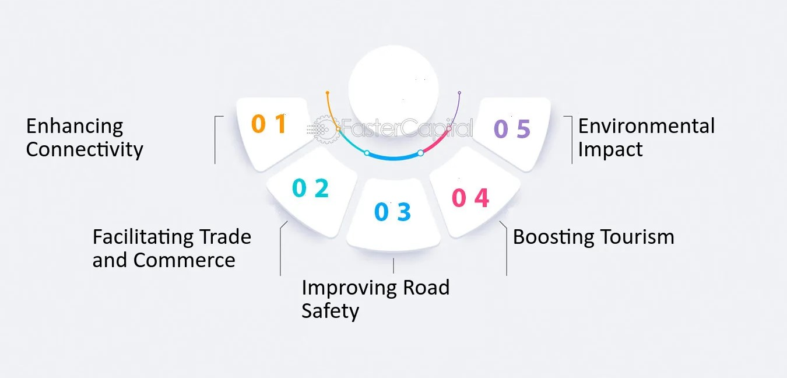

**Figure 2.1:** Understanding the Importance of Road Infrastructure

### 2.2.1 Fundamentals of road infrastructure

Effective road infrastructure hinges on these fundamental elements working in harmony:

1. Road Network: Comprising highways, streets, and rural roads, tailored to diverse transportation needs.
2. Design and Engineering: Includes road width, surface materials, drainage systems, and signage, ensuring durability and safety.
3. Maintenance and Upkeep: Crucial for prolonging road lifespan, encompassing regular inspection, repair, and resurfacing activities.
4. Auxiliary Features: Bridges, tunnels, and interchanges complement the network, facilitating seamless transitions and enhancing connectivity.
5. Traffic Management Tools: Traffic signals, road markings, and speed limit signage regulate traffic flow, ensuring safety and efficiency.

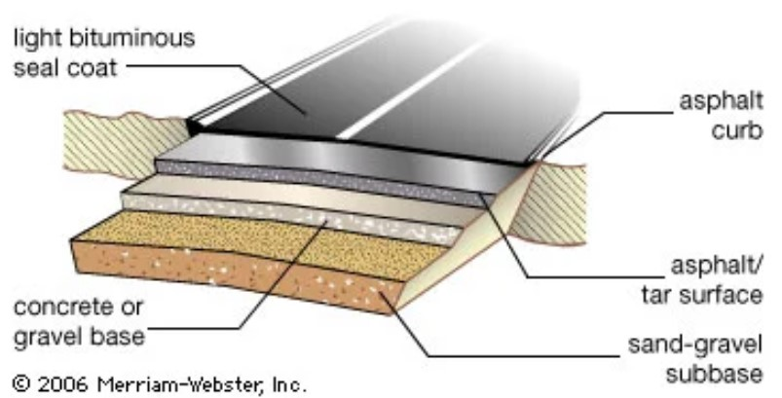

**Figure 2.2:** Elements of a modern asphalt road.

Road infrastructure serves as the backbone of transportation systems, encompassing various types tailored to distinct purposes (Parvard *et al*, 2023). Urban roads, primarily found in cities and densely populated areas, facilitate intra-city travel, connecting residential, commercial, and industrial zones. Rural roads, contrasting urban counterparts, cater to sparsely populated areas, linking villages, farms, and remote regions, often crucial for agricultural activities and rural connectivity (Ganguli, 2020). Highways, the arterial routes of transportation, connect cities and regions, facilitating long-distance travel and trade. Each type plays a pivotal role in enabling the movement of goods, services, and people, thereby fostering economic activities, enhancing accessibility, and supporting the social fabric within communities (Heinonen & Czepkiewicz, 2021)

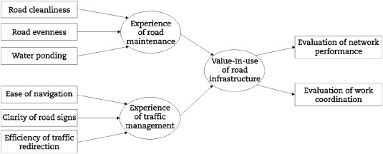

**Figure 2.3**: Road Network Model

### 2.2.2 Roles of Road in Transportation

Roads are essential for aiding mobility in a number of ways.

1. Connectivity: Roads are the main means of establishing connections between towns, cities, and rural areas. They promote cross-regional economic and social ties by facilitating the flow of people, products, and services.
2. Accessibility: They make a variety of places accessible, such as homes, businesses, industries, and vital services like hospitals and schools. The inhabitants' quality of life is improved by this accessibility.
3. Trade & Commerce: In order to move commodities between manufacturing facilities, marketplaces, and distribution hubs, roads are essential. They make trading easier by providing a dependable and easily available mode of transportation.
4. Mobility: Private automobiles, bicycles, and pedestrian walkways all contribute to the flexible and customized transportation that roads enable.
5. Economic Development: By lowering transportation costs, enhancing market accessibility, and drawing investments because of improved connectivity, efficient road networks promote economic growth.
6. Support for Agriculture: Transporting product from farms to markets is made easier by rural roads, which lowers spoilage and gives farmers access to a wider range of markets.
7. Travel and Tourism: By facilitating access to popular tourist locations, roads help the travel and tourism sector and boost local economies by drawing tourists.
8. Emergency Services: Roads allow emergency response vehicles, such as fire trucks and ambulances, to quickly access areas and provide prompt aid in times of need.

## 2.2 Historical Evolution of Road Networks

Road networks have evolved historically throughout millennia, mirroring the advancement of civilizations and the expansion of their societies. Roads began as old paths and trails made by the earliest human settlements and progressively changed to suit increasing trade, communication, and social relations. Road construction was greatly advanced by early civilizations like the Roman Empire, which created a massive network of stone-paved roads that allowed for effective trade and transit across large areas. The evolution of civilizations was influenced by these ancient highways, which not only made it easier for armies and merchandise to travel, but also acted as channels for cultural exchange (Chu, 2022).

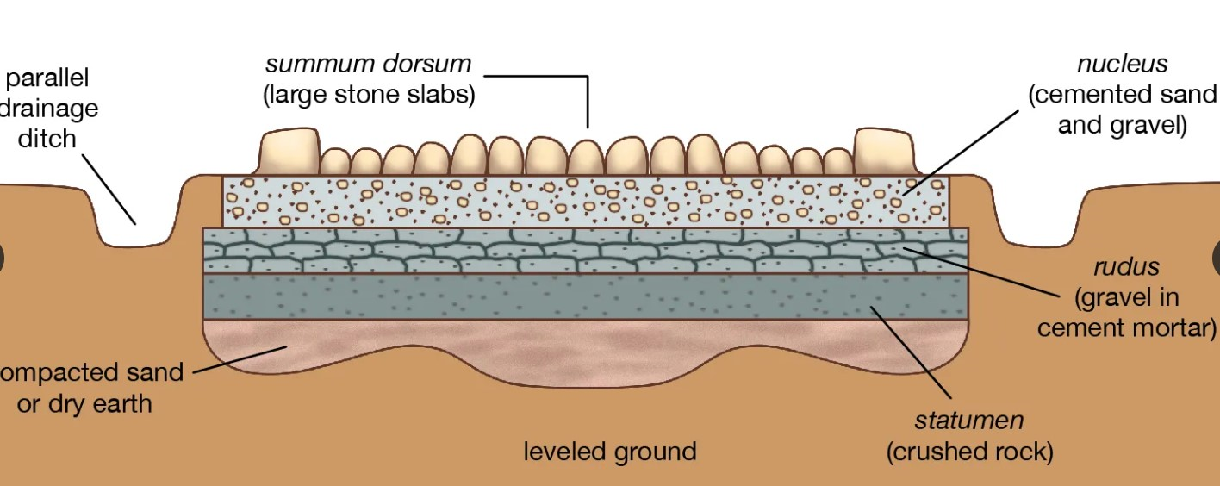

**Figure 2.4**: Ancient Roman road shown in cross section.

In the Middle Ages, wars and political turmoil caused roads to decay, leading to neglect. Turnpikes and toll roads emerged to fund maintenance. The Renaissance and industrial revolutions spurred significant road development. Steam-powered transport in the 19th century revolutionized road networks, enabling modern freeways and transcontinental routes. This era facilitated extensive mobility, trade growth, and urbanization, fostering societal progress and economic prosperity (Wang *et al*., 2020).

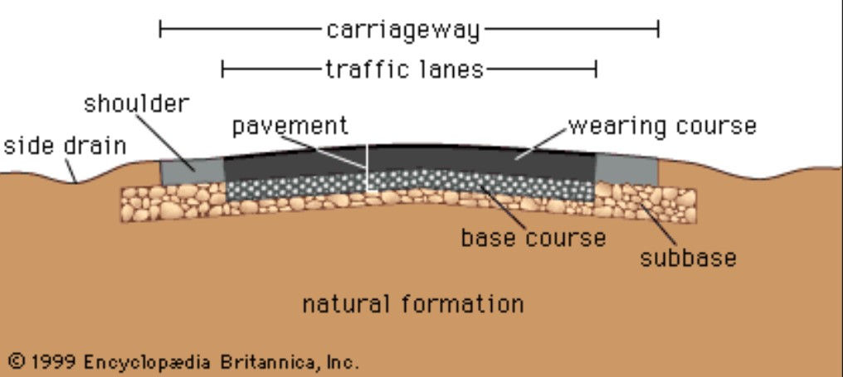

**Figure 2.5:** Schematic Cross Section of a Modern Roadway

The influence of highways on the development of society cannot be emphasized. As roads got bigger and better, they stimulated economic growth by making it possible to move goods more effectively, promoting trade, and making markets easier to access. Road networks also encouraged cross-cultural interactions and the transfer of ideas, innovations, and expertise. Roads connect villages and made it easier for people and resources to move about, which helped shape societal growth, promote regional integration (Parvard *et al*, 2023).

**Table 2.1:** Evolution of Road Infrastructure: Historical Milestones

|  |  |
| --- | --- |
| Era | Key Developments in Road Infrastructure |
| Ancient Times | Emergence of footpaths and trails for travel between settlements.  Roman Empire constructs extensive road networks, such as the Appian Way. |
| Middles Ages | Expansion of trade routes, leading to the establishment of trade roads.  Development of cobbled and gravel roads connecting towns and markets. |
| Industrial Era | Introduction of turnpikes, toll roads funded by users for maintenance.  Advancements in road construction with the use of macadam and paving stones. |
| 20th Century | Rise of automobiles leads to the construction of paved roads for cars.  Implementation of highway systems and interstate networks for long-distance travel. |
| Modern Era | Development of expressways, freeways, and high-speed motorways.  Integration of technology for traffic management and navigation systems. |

## 2.3 Road Connectivity in Urban Development

The concept of road connectivity stands as a fundamental pillar in urban development, elucidating the significance of integrated road networks in fostering societal growth. It serves as the lifeline of urban landscapes, enabling efficient movement of goods, services, and people, thereby propelling economic activities and shaping urban fabric (Maity *et al*, 2021). Urban transportation planning principles underscore the vital theories and methodologies guiding the strategic design and implementation of road networks. These principles are pivotal in orchestrating the systematic arrangement of road infrastructure to meet the evolving demands of urban spaces, ensuring accessibility, and facilitating smooth mobility within cities (Ali *et al.*, 2021).

## 2.4 Traffic Flow Analysis and Management

### 2.4.1 Traffic Flow

Traffic flow is the study of interactions between users of transportation—vehicles, pedestrians, cyclists, drivers, and their vehicles and infrastructure highways, signage, and traffic control devices. The goal is to comprehend and create an ideal transportation network with minimal issues with traffic congestion and efficient traffic movement.

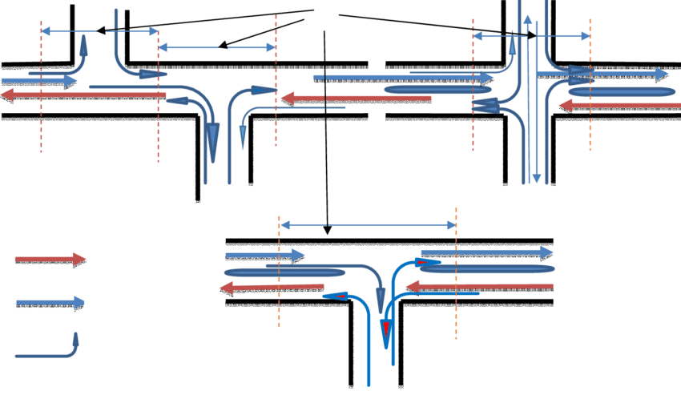

**Figure 2.6:** Schematic diagram of a traffic flow on urban road network

### 2.4.2 Types of Traffic Flow

There are two main forms of traffic flow. Understanding the sort of flow that is occurring in a specific situation will assist you in determining which analysis methods and descriptions are most appropriate.

1. Uninterrupted flow: it is flow that is regulated by vehicle-vehicle interactions as well as vehicle-roadway interactions. Vehicles going on an interstate highway, for example, are in continuous flow.
2. Interrupted flow: It is flow that has been interrupted by an external mechanism, such as a traffic signal. Vehicle-vehicle and vehicle-roadway interactions have a secondary role in defining traffic flow under interrupted flow conditions.

### 2.4.3 Traffic Flow Analysis

The process of gathering, analyzing, and evaluating data about vehicle movement on roads is known as traffic flow analysis. Traffic flow patterns allow analysts to spot locations prone to bottlenecks or inefficient traffic movement, identify trends, and comprehend the dynamics of congestion. Numerous data sources are frequently used in this study, such as sensors, traffic cameras, manual observations, and historical data.

### 2.4.4 Types of Traffic Flow Analysis

Traffic flow analysis categorizes into three primary types, each offering distinct perspectives;

**Table 2.2:** Types of Traffic Flow Analysis: Perspectives and Parameters

|  |  |  |  |
| --- | --- | --- | --- |
| Type | Focus | Parameters | Use |
| Microscopic Traffic Flow | Individual vehicles and interactions | Lane changes, acceleration, overtaking | Understanding detailed driver behaviors |
| Macroscopic Traffic Flow | Collective traffic movement on a larger scale | Average speed, traffic density, flow rate | Assessing congestion, overall traffic conditions |
| Mesoscopic Traffic Flow | Groups of vehicles and their behavior | Interactions within clusters, platooning dynamics | Understanding interactions among clusters of vehicles |

### 2.4.5 Traffic Flow Visualization

Visualizations play a crucial role in understanding traffic flow. The two key methods for visualizing traffic flow are;

1. Speed-Density Diagram
2. Flow-Density Relationship

Both visualizations help transportation experts and planners understand the dynamics of traffic. They aid in the identification of crucial thresholds when traffic conditions change, hence directing the creation of successful traffic management techniques.

### 2.4.6 Speed- Flow- Density Relationship

Speed, flow, and density are all interconnected. In the actual world, the links between speed and density are easy to see, but the impacts of speed and density on flow are less obvious.

Under continuous flow circumstances, the following equation relates speed, density, and flow:

q = k * v

Where q = Flow (vehicles per hour)

v = Speed (in miles per hour or kilometers per hour)

k = Vehicle Density (vehicles per mile, vehicles per kilometer)

Since density and speed are the products of flow, when one or both of these components are 0, the flow equals zero. Another conclusion that might be drawn is that the flow is optimized at a particular critical speed and density combination.

These concepts are demonstrated by two typical traffic scenarios. The first is the modern traffic gridlock, which is characterized by extremely high traffic density and poor speeds. A relatively low flow is produced by this combination. The second scenario is when there is very little traffic and drivers are able to move at a free flow speed without being unduly stressed out by other cars on the road. The ensuing very low flow is the result of the extremely low density making up for the high velocity.

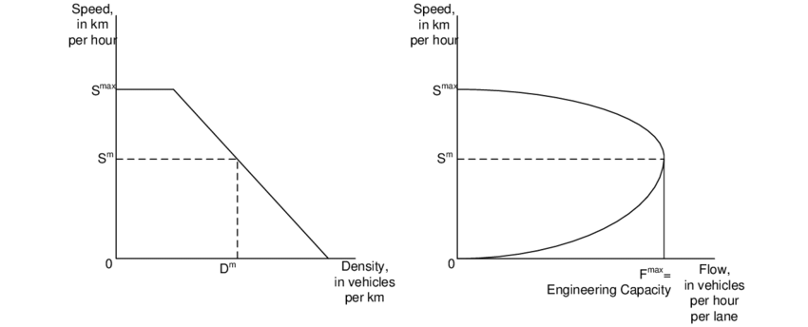

**Figure 2.7**: Speed -Density and Speed-Flow Curves

The Speed-Density Diagram delineates the correlation between traffic speed and density, highlighting that as traffic density rises, average speed typically diminishes due to congestion and increased vehicle interactions. On the other hand, the Flow-Density Relationship showcases how traffic flow changes concerning traffic density, revealing that flow often ascends with density until reaching a maximum capacity. Beyond this threshold, additional density increments yield decreased flow, reflecting the onset of congestion. These visualizations aid analysts and planners in recognizing critical thresholds where traffic conditions shift, guiding the formulation of targeted traffic management strategies to optimize road efficiency and alleviate congestion.

### 2.4.7 Traffic Flow Parameters

1. Speed (v): Distance traveled per unit of time by a vehicle. Average speed is the space mean speed calculated by averaging individual vehicle speeds.
2. Volume: Number of vehicles passing a point on a roadway in a specified time period.
3. Traffic Flow (q): Rate at which vehicles pass a given point on the roadway, usually measured in vehicles per hour.

q = ρ * v

where q = Traffic flow rate

ρ = density and v = speed

1. Peak Hour Factor (PHF): Ratio of the hourly flow rate to the peak 15-minute rate of flow expressed as an hourly flow.
2. Density (k): Number of vehicles on a given length of roadway, reported in vehicles per mile or kilometer.
3. Headway (h): Temporal space between two vehicles, measured in seconds from the arrival of the leading vehicle to the following vehicle.
4. Spacing (s): Physical distance between the front bumpers of leading and following vehicles, reported in feet or meters.
5. Gap (g): Time between the departure of the first vehicle and the arrival of the second at a designated point, measured in seconds.
6. Clearance (c): Distance between the rear bumper of the leading vehicle and the front bumper of the following vehicle, reported in feet or meters. It is the spacing minus the length of the leading vehicle.

An essential component in comprehending the complex dynamics of urban mobility is traffic flow analysis. It includes a range of approaches meant to evaluate traffic patterns, points of congestion, and their significant effects on the planning and construction of transportation networks. By utilizing methods such as density evaluations, speed analyses, and traffic volume counts, traffic flow analysis clarifies the fluctuations in vehicle movement and pinpoints locations that are vulnerable to traffic bottlenecks. This empirical knowledge allows urban planners to strategically deploy infrastructure and resources to reduce traffic demands. It also acts as a blueprint for efficient road network design (Kolesov *et al*., 2022)

In order to alleviate traffic and improve the general effectiveness of road networks, traffic management measures become essential. These tactics include lane management, intelligent transportation systems, and traffic signal optimization, among many other techniques. Urban authorities can optimize traffic flow and reduce congestion by using congestion pricing systems, adaptive traffic signals, and real-time traffic monitoring. A more sustainable and balanced urban mobility scene is also fostered by creative solutions like bike lanes, pedestrian-friendly infrastructure, and dedicated bus lanes (Kim *et al*., 2023)

Zheng and Huang (2020) conducted a study that targets urban congestion by using deep learning, specifically LSTM networks, for accurate traffic flow prediction. Comparing with traditional methods, the LSTM model proved superior in forecasting accuracy, revealing dynamic traffic patterns and aiding effective traffic management decisions using real traffic data. Overall, there research showcases deep learning's potential to enhance traffic flow analysis and management in tackling urban congestion.

## 2.5 Infrastructure Development and Management

In the field of infrastructure development, investigating various models is essential for efficient road network planning, building, and upkeep. Road design and management are shaped by a variety of techniques, ranging from conventional to cutting-edge methods, which affect the roads' sustainability and long-term viability. Furthermore, the range of urban-rural dynamics in Nigeria has a major influence on road infrastructure. Road network development and maintenance present a variety of challenges depending on the region's unique urban and rural characteristics. This necessitates customized solutions to address connectivity problems, unequal resource allocation, and differing infrastructure demands between urban and rural areas (Chang *et al*., 2023).

Within Nigeria, the perspective on road infrastructure highlights critical aspects of development and management. The country faces multifaceted challenges, including inadequate maintenance, funding constraints, and diverse terrain conditions influencing road quality across urban and rural landscapes. Urban areas often require robust and well-connected road networks to support economic activities, while rural regions demand infrastructural improvements to bridge accessibility gaps. Balancing these urban-rural dynamics becomes imperative in Nigeria's infrastructure planning, emphasizing the need for tailored strategies that consider local contexts, resource allocation, and equitable infrastructure development to foster nationwide economic growth and social cohesion (Ali *et al*., 2020).

## 2.6 Environmental Sustainability in Road Infrastructure

Henke *et al*. (2020) conducted a study focusing on decision-making within the transport sector, specifically examining a sustainable evaluation method for road infrastructure. They addressed the significant concern around negative externalities generated by daily transportation activities, impacting both the environment and quality of life. The research aimed to propose a sustainable assessment method for evaluating the impacts of new transportation infrastructure. Their quantitative analysis assessed social, economic, and environmental sustainability concerning a renovation project for a "greenway" in southern Italy.

Ben (2021) explored the significance of road infrastructure on economic sustainability, emphasizing its crucial role in eradicating hunger, reducing poverty, and enhancing human life quality. The study highlighted road transport as a door-to-door means of transportation vital for delivering finished goods to consumers. Additionally, it underscored how road infrastructure can transform subsistence farming into a thriving commercial system, unlocking rural areas' potential. The paper discussed various economic theories, including neoclassical growth theory, endogenous growth theory, growth pole, and growth center theory, to understand how road infrastructure contributes to economic growth. It concluded by advocating for public investment focused on economic returns, proposing the adoption of road pricing strategies in Nigeria to spread demand, reduce congestion, improve reliability, and benefit the broader economy.

Ruiz & Guevara (2020) examined road infrastructure's environmental and economic impacts using a system dynamics approach. Their study compared traditional and sustainable techniques in road construction and maintenance, emphasizing the importance of prioritizing sustainable practices in maintenance over green methods in new construction. Their research highlighted the significant effect of maintenance on costs and emissions, recommending a focus on road maintenance to enhance road network conditions. It proposed their model as a tool for policy development and suggested further research on green interventions in existing road networks globally.

## 2.7 Environmental impact assessment

The study by (Mavrin *et al*., 2020) addresses road transport's environmental impact by focusing on enhancing traffic management efficiency through infrastructure modernization. They analyzed problematic areas within a medium-sized city's street and road network, creating simulation models using a discrete-event approach. The study proposed measures for modernizing these areas and conducted computer experiments, revealing substantial potential for improving traffic flow parameters and subsequently reducing environmental impact. This research emphasizes evidence-based methods for managing traffic effectively and suggests practical steps for infrastructure enhancement in urbanized areas.

In this paper by Onokala & Olajide, (2020), the focus is on highlighting the challenges faced by Nigeria's major transportation modes in contributing to the country's economic development in the 21st century. They extensively reviewed the historical development of each mode—road, waterways, railways, and airways—and its past role in economic progress. The study delves into the present challenges, with a major emphasis on the overuse and mismanagement of road transport, underutilization of waterways' capacity, outdated railway systems, and the need for significant enhancements in air transport. These challenges result in environmental issues, frequent road accidents, port inefficiencies, and missed opportunities for imports at Nigerian seaports. The paper concludes by proposing sustainable approaches to address these challenges and enable these transportation modes to better contribute to Nigeria's economic growth in the 21st century.

## 2.8 Sustainable road network models

In Nabeeh’s (2023) research, the focus was on assessing sustainable growth in diverse road transport systems using an Intelligent Neutrosophic Multi-Criteria Decision-Making (MCDM) model. The study examined environmental and economic facets, emphasizing the need to reduce carbon emissions, enhance energy efficiency, and consider broader societal objectives. It employed the MCDM model to balance competing factors like environmental impact, energy efficiency, legislative frameworks, and economic influence. By incorporating a DEMATEL approach and 14 secondary criteria, the research aimed to comprehensively evaluate the progress of current road transport systems towards sustainability, aiding stakeholders in future planning for sustainable transportation.

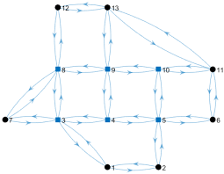

**Figure 2.8:** Dynamic Road Network Model

In their study, Ruiz and Guevara (2020) delved into sustainable decision-making for road development, specifically focusing on road preservation policies in Colombia. Their hybrid methodology merged system dynamics (SD) and analytic hierarchical process (AHP) approaches to assess various strategies for sustainable road maintenance. Through a hypothetical case study of Colombia's national road network, they evaluated maintenance policy options using the SD model, analyzing road conditions, costs, and emissions. The findings emphasized that economic influences often drove short-term maintenance strategies, favoring corrective over predictive maintenance. However, the analysis highlighted that predictive maintenance significantly contributed to maintaining roads in good condition and reducing CO2 emissions.

In the study conducted by (Ogryzek *et al*., 2020) the authors described principles and practices for developing a more efficient transportation network in cities. They drew examples from cities like London and Copenhagen, while analyzing Vilnius' sustainable transport rules and mobility. The research explored various components influencing sustainable transport, such as public transport indicators, car usage, cycling, and pedestrian trips. It proposed solutions like shared space, cycle route development, and policy shifts. These were all examined through the use of geographic information system (GIS) tools and graph theory algorithms.

# REFERENCES

Ali, L., Khan, S., Shah, S. J., Ullah, A., Ashraf, H., Ahmad, M., Begum, A., Han, H., Ariza-Montes, A., Araya-Castillo, L., Khan, A. U., Anas, M., & Khan, A. M. (2021, December 6). *Road and Transportation Lead to Better Health and Sustainable Destination Development in Host Community: A Case of China Pakistan Economic Corridor (CPEC)*.

Munir, T., Dia, H., & Ghaderi, H. (2021, October 31). *A Systematic Review of the Role of Road Network Pricing in Shaping Sustainable Cities: Lessons Learned and Opportunities for a Post-Pandemic World*.

Akinola, S. F. (2023). *Using GIS Network Modeling to Evaluate Access Disruption to Critical Health Facilities During Flood Events*. Scholar Works @ *Georgia State University.*

Khuvung, Z., & Odyuo, M. N. (2023, May 23). Study on the Impact of the Nationwide Rural Road Connectivity Programme in India (PMGSY) on the Socio-Economic Status of the Rural People under Wozhuro Rural Development Block, Wokha District, Nagaland, India. *Asian Journal of Agricultural Extension, Economics & Sociology*, *41*(7), 199–208.

Oluwaseyi, A. D. (2021, April 6). *Indoor Environmental Quality of Households Resident Districts Within Ogbomoso Township, Nigeria | LC International Journal of STEM (ISSN: 2708-7123)*. Indoor Environmental Quality of Households Resident Districts Within Ogbomoso Township, Nigeria | LC International Journal of STEM (ISSN: 2708-7123).

Pavard, A., Dony, A., & Bordin, P. (2023). *Road Modelling for Infrastructure Management – The Efficient Use of Geographic Information Systems.* Paper Under-review since 2023.03.13.

Ganguli, B. (2020, November 12). *Rural Road Connectivity: The Artery of the Economy*. Rural Road Connectivity: The Artery of the Economy by Barna Ganguli: SSRN.

Heinonen, J., & Czepkiewicz, M. (2021, June 9). *Cities, Long-Distance Travel, and Climate Impacts.* *Urban Planning*, *6*(2), 228–231.

Chu, B. B. (2022, October 25). The historical significance of the silk road. *Значение Цифровых Технологий В Изучении Истории Узбекистана*, *1*(01), 410–412.

Wang, Yu, Kwan, Zheng, Miao, & Li. (2020, November 21). *The impacts of road network density on motor vehicle travel: An empirical study of Chinese cities based on network theory* - ScienceDirect.

Maity, B., Mallick, S. K., & Rudra, S. (2021). *Integration of urban expansion with hybrid road transport network development within Haldia Municipality, West Bengal*. The Egyptian Journal of Remote Sensing and Space Science, 24(3, Part 1), 471-4832.

Kolesov, V. I., Sorokin, D. A., & Gulyaev, M. L. (2022). *Urban Mobility Management By Means Of Traffic Flow Dynamics*. *Транспорт Наука Техника Управление*, *8*, 3–10.

Kim, J., Jang, H., Han, E., & Ko, E. (2023, October 31). Analysis of Traffic Flow Based on Autonomous Vehicles’ Perception of Traffic Safety Signs in Urban Roads. *The Journal of the Korea Institute of Intelligent Transport Systems*, *22*(5), 148–162.

J. Zheng and M. Huang, "*Traffic Flow Forecast Through Time Series Analysis Based on Deep Learning*," in IEEE Access, vol. 8, pp. 82562-82570, 2020.

Ali, R., Barra, A. F., Berg, C. N., Damania, R., Nash, J., & Russ, J. (2020, May 1). *Transport Infrastructure and Welfare: An Application to Nigeria*. Transport Infrastructure and Welfare: An Application to Nigeria.

Henke, I., Cartenì, A., Molitierno, C., & Errico, A. (2020, January 21). *Decision-Making in the Transport Sector: A Sustainable Evaluation Method for Road Infrastructure*. MDPI.

Ben, S. O. (2021, October 5). *Significance of Road Infrastructure on Economic Sustainability | American International Journal of Multidisciplinary Scientific Research*. Significance of Road Infrastructure on Economic Sustainability | American International Journal of Multidisciplinary Scientific Research.

Ruiz, A., & Guevara, J. (2020, May). Environmental and Economic Impacts of Road Infrastructure Development: Dynamic Considerations and Policies. *Journal of Management in Engineering*, *36*(3).

Mavrin, V., Magdin, K., Shepelev, V., & Danilov, I. (2020). Reduction of environmental impact from road transport using analysis and simulation methods. *Transportation Research Procedia*, *50*, 451–457.

Ogryzek, M., Adamska-Kmieć, D., & Klimach, A. (2020). *Sustainable Transport: An Efficient Transportation Network—Case Study. Sustainability*, 12(19), 8274.